Name:

/23

**Year 8 Cells Mini Test**

Look at the diagrams on the next page. One is a plant cell and one is an animal cell

Which one is which? 3

* Top:_____________________
* Bottom:___________________

How could you tell?

Look at the names below. Use these names to label each diagram. Some of the names will be used on both diagrams, others will only be used on one diagram. Not all the organelles on each diagram will be labelled. 11

* Nucleus
* Cytoplasm
* Cell wall
* Cell membrane
* Mitochondria
* Chloroplast
* Vacuole

Match the names below with their function: 8

*Nucleus, Cytoplasm, Cell wall, Cell membrane, Mitochondria, Chloroplast, Vacuole. Ribosome*

|  |  |
| --- | --- |
| **Organelle Name** | **Function** |
|  | To provide support for the cell |
|  | The control centre of the cell |
|  | Contains Chlorophyll which is needed for photosynthesis and makes plants green |
|  | Filled with fluid, used to store water and nutrients |
|  | Where cellular respiration happens to provide energy for the cell |
|  | The jelly like substance that fills the cell |
|  | Surrounds the cell to hold it together and control what enters and leaves |
|  | Where proteins are produced |

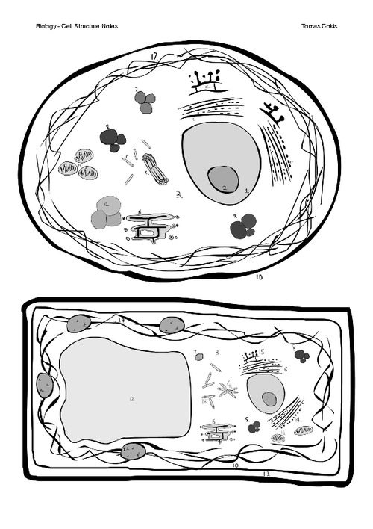

What term is used to describe the parts of a cell? _________________________ 1